Overview of Neural Networks

Shreenidhi Sudhakar

Dept. of ECE, Florida Institute of Technology, 150 W University Blvd, Melbourne, FL 32901

Abstract
The paper discusses the implementation of Neural Network using Back Propagation Algorithm. It compares the iteration count required to converge to local minima by using batch and stochastic gradient descent methods. 3-fold cross validation technique is used to find the average iteration count needed to converge. Two distinct datasets namely, iris1 and car evaluation2 have been used to carry out the above experiment. It’s found that the stochastic gradient descent converges sooner when compared to batch gradient descent. This fact should not convince people to use stochastic gradient method always as it can prove to be expensive and time consume when we deal with large datasets. The report also clarifies the notion of using variable learning rate with a general intuition. The experiment carried out here meant to reduce learning rate by half each time the cost function found was less than twice the assumed threshold error. Intuitively it might seem that we will converge sooner as we can assume a high learning rate initially. But experiments carried out to prove that the accuracy and time required to reach local minima is the same in both traditional and the approach discussed here.

Keywords: Neural network, back propagation, gradient descent, minima, learning rate, cross validation, momentum
- INTRODUCTION
Neural Network design was inspired from human brain. It consists of set interconnected nodes that mimic the nerve structure of a brain. The interconnected node structure can be visualized to be the multiple layers of the neural network. Each node needs to be fed with an input greater than a predefined threshold value for it to operate. The input is traversed from input layer to output layer via the many activation units present in the various layers of the neural network.
Neural networks were introduced as an upgrade to the perceptron’s in the middle of 20th century. The reason for the failure of perceptron was that it couldn’t classify non-linear data efficiently because of time and space complexity. Neural networks eased the classification of non-linear data by introducing a activation unit like sigmoid to convert non-linear data to linear form.
Neural network also has its share of downfalls. After tasting initial success in classification, it became obsolete in its usage between 1970– 2005. The major reason behind this was the lack of technology during those years to compute calculations of high magnitude. With introduction parallel computing in the early 2000, neural network came into prominence in the name of Deep Learning. Neural networks based on deep learning are complex and accurate. Some of the most commonly used variations of neural networks in the market are Convolutional Neural Network (CNN), Recurrent Neural Network (RNN), Long Short Term Memory (LSTM) and Boltzmann machine. These are used widely in image classification, predictive analysis and speech recognition.
In this report, we concentrate on implementation of a simple 3 layer neural network to classify data from two different datasets, namely iris and car evaluation. Accuracy of neural networks is computed based on different descent method used to update the weight parameters. Here, we have used 3-fold cross validation technique to compute the average number of steps needed to find local minima. The effects of using a variable learning rate with general are also discussed.
Contents
- 2 PR Model Description
- 3 Experimental Results
- 4 Discussion
- 5 References

PR Model Description

2.1 1: K Hot Encoding
Neural network can handle only discrete data. Hence, we have to pre-process the data sample in-order to ensure that the data being fed to the neural network is discrete in nature. Thus, we have to use 1:K encoding method to ensure conversion of any non-discrete input to its discrete form.

2.2 Data Splitting
Dataset is split into 3 distinct sets, namely training set, validation set and test set. The training set is fed into the neural network to train it. Validation set is used in-order to compute the accuracy of the network. This done by using the weights computed during training stage. If the accuracy of validation set is found to be less than the expected values, we change neural network parameters and train it again. This process continues until we are satisfied with validation set accuracy. Next we check the accuracy of test set. If we are satisfied, we stop training the network. Else we change parameters of network and check for validation and test accuracy.

2.3 Feed Forward
Training samples are fed to the input layer of neural network. These are traversed to the output layers of neural network as shown in the figure. In general, result of any hidden/output unit is the weighted sum of the weights (passing through the activation unit) that are contributing to the output of the node that is being computed.

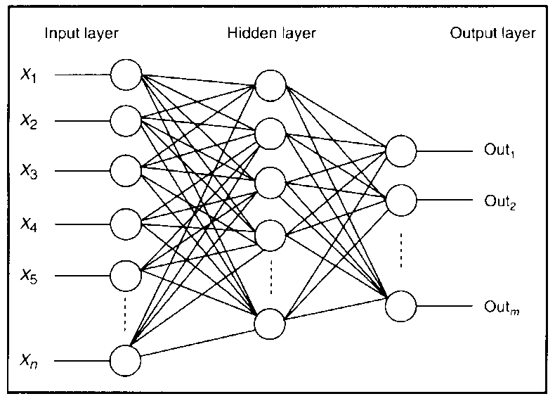

Figure 1 Structure of 3 Layer Neural Network

2.4 Activation Unit
Activation units are the ones that are responsible for conversion of non-linear data to its linear form. In this project, we have used a sigmoid function for data transformation. Sigmoid function is chosen as its differentiable and its output lie between 0-1. We can use hyperbolic tangent function for data transformation also.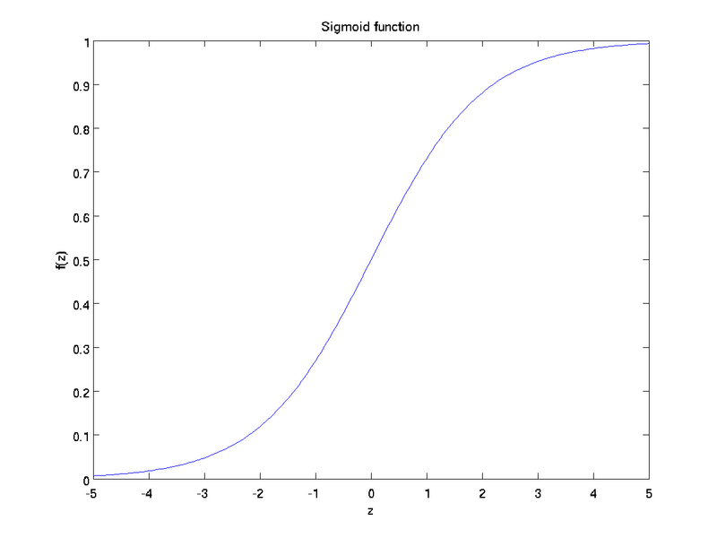

Figure 2 Sigmoid function

2.5 Back Propagation
he predicted output of the neural network is compared with its actual output. The difference in their values is used to compute the gradient value of the hidden layer. The actual output of the hidden units is computed as the weighted sum of all the output units that originated from the corresponding hidden unit. The difference in the values of actual and predicted hidden unit output is used to compute the gradient of the input layer. As we are traversing the neural network from output to input in-order to compute the gradients, we call this algorithm as Back Propagation Algorithm.
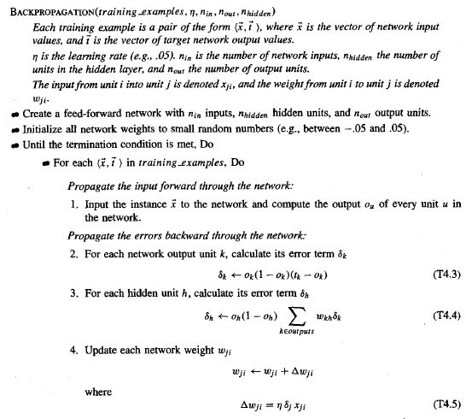
Figure 3 Back Propagation Algorithm

2.6 Gradient Descent
Two gradient descent methods are used in common to update the weights of the neural network. They are called the batch gradient descent and stochastic gradient descent methods. In case of the former, the weights are updated once we have finished computing the error in network node values for all the training examples present in the dataset. This technique is used often when we have a large dataset in-order to reduce the training time of the network. In case of the latter, the weights are updated every time we compute the error in network node values for each training example present in the dataset. This technique is used often when we have a small dataset in-order where accuracy of network is of high priority.

2.7 Local Minima

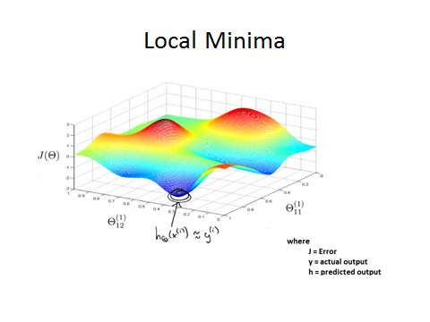
Figure 4 Finding Local Minima of Neural Network

The cost function of neural network is computed after we iterate through all the data samples of neural network once. This value is compared with threshold error assigned to check for convergence. If the condition is satisfied, training of neural network is halted. Else, we repeat the above process until convergence. It’s not guaranteed to find a local minimum after training the neural network. This is because the probability of landing in a false minimum is high.

2.8 Learning Rate
The probability of landing in a false minimum can be avoided by choosing the learning rate after iteration wisely. This is because learning rate directly affects the amount by which we descent after each iteration. Choosing a very small value of learning rate, increases the time required to reach the minimum. Choosing a high value on the other hand, increases the risk of missing the local minima. This results in unnecessary to and fro traversal in the region of local minima. It in turn causes a delay in finding the region of local minima.
There are methods of choosing a variable learning rate to facilitate faster convergence. This paper doesn’t focuses on these aspects. Rather it focuses on a failed attempt in implementation of variable learning rate based on a general intuition. It was assumed that reducing the learning rate by 0.5 each time cost function is less than 2 times the threshold error would result in faster convergence. This notion proved to be wrong as results obtained show the results of both approaches were identical. Rather using the idea about the general notion proved to be worse under certain conditions.
Momentum is added during weight update in-order to enable the process of reaching the local minima faster.
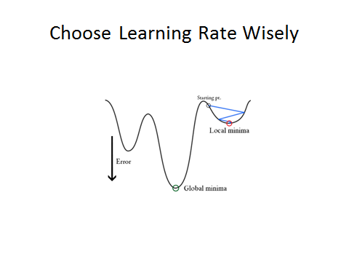
Figure 5 Effects of Learning Rate on Convergence

2.9 Cross Validation
Cross validation is implemented in the project to find the average iteration time required to complete the training the neural network. The project uses a 3 fold cross validation technique.

2.10 Pros and Cons
The advantage of our 3 layer neural network is that it can be used to classify non-linear data with high precision. The disadvantage on the other hand is that we cannot draw any conclusions regarding the relative importance of features used in our model by observing the weights of the neural network.

Experimental Outcomes
The results of the experiment carried out are represented in form of table below.

3.1 Batch Gradient Descent

Table 1. Results of neural network wrt Iris dataset
Learning Rate | Iris
Learning Rate | Validation Set Accuracy | Test Set Accuracy | Training Converged | 3-Fold Cross Validation Error | Average Iteration Count
2 | 92.20 | 91.30 | False | 6.17 | 4000+
3 | 93.93 | 94.20 | True | 4.24 | 3831
4 | 94.51 | 94.20 | True | 4.72 | 2643

Table 2. Results of neural network wrt Car Evaluation dataset
Learning Rate | Car Evaluation
Learning Rate | Validation Set Accuracy | Test Set Accuracy | Training Converged | 3-Fold Cross Validation Error | Average Iteration Count
1 | 94.51 | 91.30 | True | 5.78 | 309
2 | 95.66 | 93.04 | True | 6.46 | 277
3 | 95.38 | 93.91 | True | 6.65 | 260

3.2 Stochastic Gradient Descent

Learning Rate | Iris
Learning Rate | Validation Set Accuracy | Test Set Accuracy | Training Converged | 3-Fold Cross Validation Error | Average Iteration Count
0.1 | 94.80 | 93.33 | True | 5.30 | 341
0.2 | 96.24 | 94.20 | True | 3.86 | 290
0.3 | 92.20 | 92.17 | True | 5.30 | 209
Table 3. Results of neural network wrt Iris dataset

Table 4. Results of neural network wrt Car Evaluation dataset
Learning Rate | Car Evaluation
Learning Rate | Validation Set Accuracy | Test Set Accuracy | Training Converged | 3-Fold Cross Validation Error | Average Iteration Count
0.1 | 96.67 | 96.67 | True | 1.11 | 385
0.2 | 96.67 | 96.67 | True | 1.11 | 324
0.3 | 93.33 | 96.67 | True | 1.11 | 244

Discussion
The implementation of neural network is simple when implemented on platforms like MATLAB as it has features that enable us to plot graphs and perform matrix multiplication. The current neural network model can be further improved by using regularization to avoid over-fitting. Further, it is advised to mean normalize the data before it’s fed into neural network. This ensures that the classification of data will not be heavily dependent on a particular feature. Finally, usage of line search algorithm is suggested in case of batch gradient descent to ensure speedy convergence to data.

Refrences
- Martin Riedmiller., and Heinrich Braun A Direct Adaptive Method for Faster Back propagation Learning: The RPROP Algorithm 1993, pp 586 - 591
- Yong Li, Yang Fu, Hui Li and Si-Wen Zhang. The Improved Training Algorithm of Back Propagation Neural Network with Selfadaptive Learning Rate 2009 pp 73-76
- Omaima N. Ahmad AL-Allaf. Fast BackPropagation Neural Network Algorithm for Reducing Convergence Time of BPNN ImageCompression 2011 pp 1-6
- Principles of Neurocomputing for Science and Engineering, Fredric M. Han and Ivica Kostanic
- Machine Learning By Tom Mitchell
- Pattern Recognition By Christopher Bishop
- Machine Learning By Professor Andrew N G
- Learning From Data By Professor Yaser Abu-Mostafa
- http://archive.ics.uci.edu/ml/datasets/Car+Evaluation
- http://archive.ics.uci.edu/ml/datasets/Iris?ref=datanews.io

